PROJECT REPORT

DRIVER DROWSINESS DETECTION USING
COMPUTER VISION

Name: Shrestha Agarwal
Registration Number: 24BAI10286
Course: Computer Vision
Course Code: CSE3010
University: VIT Bhopal University

Table of Contents

- Abstract
- Introduction
- Problem Statement
- Objectives
- Related Work/ Background
- Methodologies
- Technology Used
- Result
- Limitations
- Future Work
- Conclusions
- References

- Abstract
One of the major contributor to road accidents is driver fatigue , that is , a driver driving a vehicle while feeling very tired or sleepy . This project implements a real time and camera based driver drowsiness detection system using computer vision methods. The detection system finds a driver’s face and eyes using facial landmark detection and calculates the Eye Aspect Ratio (EAR) , a mathematical measure of how open each eye of the driver is and monitors them over continuous video frames. If the EAR value remains under a threshold for a large interval of time , the system classifies the driver as drowsy and triggers the warning. This approach does not require training a deep learning model instead it relies in a pretrained facial landmark model combined with simple, interpretable geometric and temporal rules .

- Introduction
Driver drowsiness can reduce focus which will automatically reduce a driver’s response to unexpected situations. Thus , continuous monitoring of driver’s alertness can help as precaution safety mechanism.
Computer Vision provides techniques for observing and analyzing images and videos to extract useful information about a person’s face and eyes. In this project, facial landmarks are used to find the important points nearby eyes of the person. These points are used to calculate the Eye Aspect Ratio (EAR) , that tells whether the eyes of the driver is open or closed.
The system continuously processes the video frames and observes changes in the driver's eye state. Closing of a single eye such as a normal blink, does not immediately lead to drowsiness warning. Instead, closing of eyes for long interval of time over continuous frames is considered as possible drowsiness.

- Problem Statement
Developing a computer vision based system that is capable of monitoring a driver's eye state through camera and detects possible drowsiness based on eye closure interval .
The system should:
- Capture video frames from a camera.
- Detect the driver's face.
- Finds facial landmarks nearby the eyes.
- Calculate the Eye Aspect Ratio (EAR)
- Tells whether the eyes are open or closed.
- Monitor closing of eyes across consecutive frames.
- Gives a warning when closing of eyes detected for long time.
- Gives the output through a simple executable program.
4. Objectives
- Detect face in every video frame with the help of pretrained landmark model.
- Finds eye-region landmarks and calculates Eye Aspect Ratio (EAR).
- Apply a threshold-based, temporal (multi-frame) decision rule to differentiate between normal blinks and drowsiness.
- Gives real-time visual and optional audio feedback.
- Log detection results for later analysis/evaluation.
- Pack the system as a reproducible, command-line-executable project.

5. Related Work / Background
Drowsiness detection based on eye closure has been extensively explored in the computer vision literature. The concept of Eye Aspect Ratio was introduced by Soukupova & Cech (2016) as a cheaper and more efficient approach to drowsiness detection than image processing methods such as computing pixel area of the eyelids or classifying cropped eye patches, which are very computationally expensive compared to EAR. As EAR computation is done directly using a small number of geometric landmarks, it is computationally inexpensive and does not require heavy GPU computations other than landmark detection. This project utilizes the above formulation with MediaPipe Face Mesh, a pre-trained publicly available model provided by Google.

6. Methodology
6.1 Pipeline overview
Step1: START - Capture video frame
Step 2: Detect driver's face (MediaPipe Face Mesh)
Step 3: Locate eye landmarks(6 points per eye)
Step 4: Calculate EAR (average of both eyes)
Step 5: Is EAR below threshold?
    - NO - ALERT
    - YES - Increment closed- frame counter
- Counter >= N consecutive frames?
- NO - ALERT
- Yes - DROWSY - on screen warning or alarm, optional
6.2 Eye Aspect Ratio (EAR)
For six landmark points p1, p2, p3, p4, p5, p6 around one eye:
EAR = (‖p2 − p6‖ + ‖p3 − p5‖) / (2 · ‖p1 − p4‖)
- (p2 − p6) and (p3 − p5) are the two vertical eyelid distances.
- (p1 − p4) is the horizontal eye-corner distance.
When the eyes are open, vertical distances are large, that gives a higher EAR (typically ~0.25–0.35 ). When the eye are closed , the vertical distances reduces to zero while horizontal distance stays almost constant, so EAR reduces sharply (typically below ~0.20). The system averages the EAR of left and right eye each frame to reduce the noise from a single eye being partially occluded or at an angle.

6.3 Temporal decision rule
However, one such low value for the EAR frame is not sufficient as proof of drowsiness since a normal blink also gives a dip in EAR value. Therefore, there is a counter that keeps track of number of frames where EAR value is lower than the threshold value. This counter is checked against another threshold and if the number of frames reaches a threshold number of frames (`--consec-frames`, with default value 20 frames – or approximately 0.6 to 1 second), then the system moves to DROWSY state.

6.4 Implementation
- Face/landmark detection: MediaPipe Face Mesh, which provides 468 3D landmarks for every face detected from a single RGB frame.
- EAR calculation: Written from scratch using NumPy in `eye_utils.py`, responsible for the distance calculation.
- Video Input/ Output and visualization: Using OpenCV for capturing input frames, drawing eye outline and status text on top of every frame, and also for saving an output annotated video file.
- Alerts: Always showing an on-screen alert, which can be also accompanied by playing a `.wav` file as an alarm sound in a separate thread.
- Logging: All the frames' EAR value, status classification and drowsiness events triggering is logged into a CSV file for later analysis.

7. Technologies Used
- Language - Python 3
- Face/landmark detection - MediaPipe Face Mesh (pretrained)
- Video capture, drawing, display - OpenCV
- Numeric computation - NumPy
- Optional audio alert - playsound

Dataset Collection and model training was not required because the landmark detector is a pretrained, general-purpose model and the drowsiness decision itself is a deterministic, rule-based calculation on top of its output.

8. Result
The system was tested by running it against short videos using webcam containing
(a) a subject with eyes open/blinking normally, and
(b) a subject with eyes closed for several consecutive seconds.

Alert state (eyes open):
EAR: 0.29
Status: ALERT
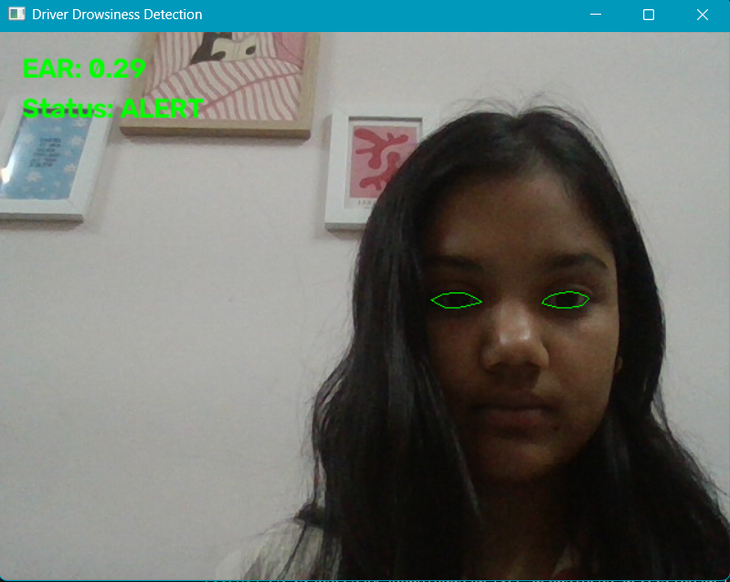

Drowsy state (eyes closed for >20 consecutive frames)
EAR: 0.10
Status: DROWSY
WARNING: DROWSINESS DETECTED
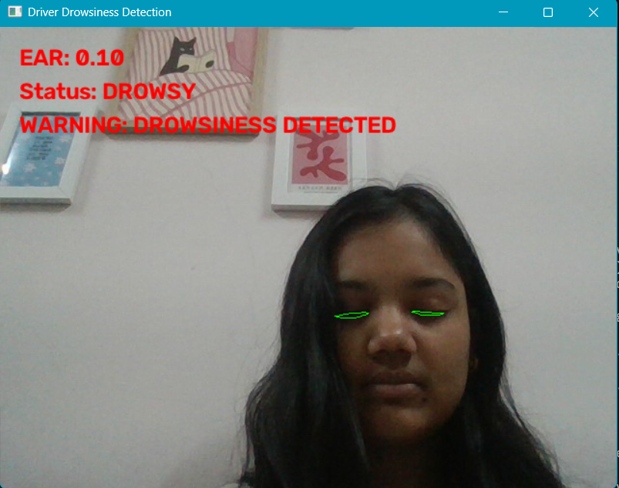

Session Summary:
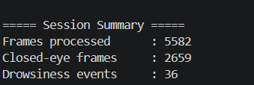

Across test runs:
- The normal blinks were detected properly as `EYES CLOSED` state, but didn’t generate a `DROWSY` event, validating the consecutive frame requirement as it effectively ignored the blinks.
- The prolonged closing of the eye resulted in the generation of a `DROWSY` event after almost one second, matching the value of `--consec-frames` parameter at the current frame rate.
- The timestamped per frame CSV log (`results/detection_log.csv`) provides complete information about EAR value and state transitions for each run, and it can be used to calculate performance metrics like closed eyes duration and number of drowsiness events.

8.1 Evaluation metrics tracked per run
- Total frames processed
- Total closed-eye frames
- Number of distinct drowsiness events
- Elapsed processing time
These are printed as a session summary at the end of every run and are also derivable from the CSV log.

9. Limitations
- Lighting sensitivity: in environments with low light levels or strong backlighting will degrade landmark recognition performance, thus decreasing the EAR robustness.
- Occlusion: occlusions like masks, hands, and unusual head orientations can result in a loss of facial mesh tracking.
- Eyewear: glasses, particularly those causing glare or dark sunglasses, can occasionally skew eye-landmarks positioning.
- Threshold generalization: EAR threshold is constant and not individually tailored; the geometry of eye shape and camera orientation differ from user to user and hence the value `0.25` may require tuning.
- Safety certification: this is an academic prototype and should not be considered a certified vehicle driver monitoring system.

10.Future Work
1.Per-user EAR calibration (a short "open eyes" / "closed eyes" baseline capture at startup).
2.Combine EAR with additional cues such as head-pose (nodding), yawning detection (mouth aspect ratio), or blink-rate trends for a more robust multi-signal fatigue score.
3.Package as a small desktop application with configurable alert sounds/visual themes.
4.Quantitative evaluation against a public drowsiness-detection benchmark dataset with ground-truth labels (e.g. precision/recall of drowsy-event detection).

11. Conclusion
In this project, we showcase a fully functioning, replicable, real-time computer vision pipeline to detect driver drowsiness using only classical approaches: pretrained facial landmarks detector, geometric measure of eye openness (EAR), and simple temporal decision function. The system can be run from the command line interface, processes webcam feeds as well as recorded videos and outputs visual output in real time as well as logs of the analysis for further study – which meets the criteria of an easy-to-explain prototype..

12. References
1. Soukupová, T., & Čech, J. (2016). *Real-Time Eye Blink Detection using Facial Landmarks.* 21st Computer Vision Winter Workshop.
2. Google MediaPipe Face Mesh documentation.
3. OpenCV documentation.

